**Software Engineering Tools Lab Assignment No-1**

(Module 1- Introduction to FOSS) **Due date-29/01/2023**

**NAME: KIRAN SAMPATRAO PATIL.**

1. Differentiate in between free software, Open-source software and proprietary software with respect to its properties.

**Answer:**

Free software: Free software are available for user to use freely. User can use, modify and distribute the software without any technical or commercial restriction from provider and developer.

Open-Source Software: Open-Source Software are software available for free use. User can use, modify and contribute to the community But, before contributing the code is checked by certain people in community to allow the code to be published in the Open-Source community.

Proprietary Software: Proprietary software are software available for user to use but, user needs to accept the Term and Condition of the community which developed that software.

1. Enlist some examples along with its purpose and properties (at least 10) of FOSS and proprietary software with respect to database.

**Answer:**

**FOSS Software:**

1. MySQL –

Purpose: Provides database services.

Properties:

* Efficient in most cases but, slower for larger database.
* Debugging tools are better than other software.
* Data corruption instance are noticed.

1. MariaDB –

Purpose: Provides database services.

Properties:

* Uses Aria storage engine to handle complex queries which gives it boost over MySQL.
* Able to use dynamic rows for table columns.
* Specialised storage engines for specific use cases.

1. PostgreSQL –

Purpose: Provides database services.

Properties:

* Implement asynchronous replication.
* Native support for JSON-style document storage, key-value storage and XML.
* Several build-in data types will be invaluable to some application.

1. Redis –

Purpose: Stores data in key-value pairs and in memory storage solution.

Properties:

* Entire storage in RAM and read-write operation are fast.
* Learning it is few minutes task.
* Can set expiry time to strings, which is a critical component of caching.

1. SQLite –

Purpose: Provides database services and is light weight tool.

Properties:

* Developer’s choice for simple application.
* Great for low traffic websites.
* Performance index increases.

1. Neo4j –

Purpose: Provides facility for storing data in the form of graph.

Properties:

* Turns tabular data into graphs and support resultant analytics.
* Stellar for transactional applications too.
* Cypher is dedicated language to use while working with it.

1. OrientDB –

Purpose: Provide graph based data storage.

Properties:

* Can turn several models into the graph data.
* Flexible and Scalable than Neo4j.

1. CouchDB –

Purpose: Distributed data storage system.

Properties:

* Data is distributed in node of clusters.
* Offline tolerance.

1. FirebirdSQL –

Purpose: Provide database services and compatible with MySQL.

Properties:

* Requires less memory.
* Help to run large databases.

1. BigchainDB –

Purpose: Distributed database blend with blockchain technology.

Properties:

* Similar to Blockchain.

1. Enlist some examples of free open-source exam software for online assessment.

**Answer:**

1. TCExam
2. VirtualX
3. Moodle
4. TAO
5. Kaldin
6. Papershala
7. Edbase
8. Mettl
9. FlexiQuiz
10. Eklavvya
11. Think Exam
12. Demonstrate any one exam software which is open source and freely available.

**Answer:**

Exam Setter User Experience –

User can add the questions of subjective, objective types objectives of single and multiple answers according to need. User can decide the limit of the subjective answer.

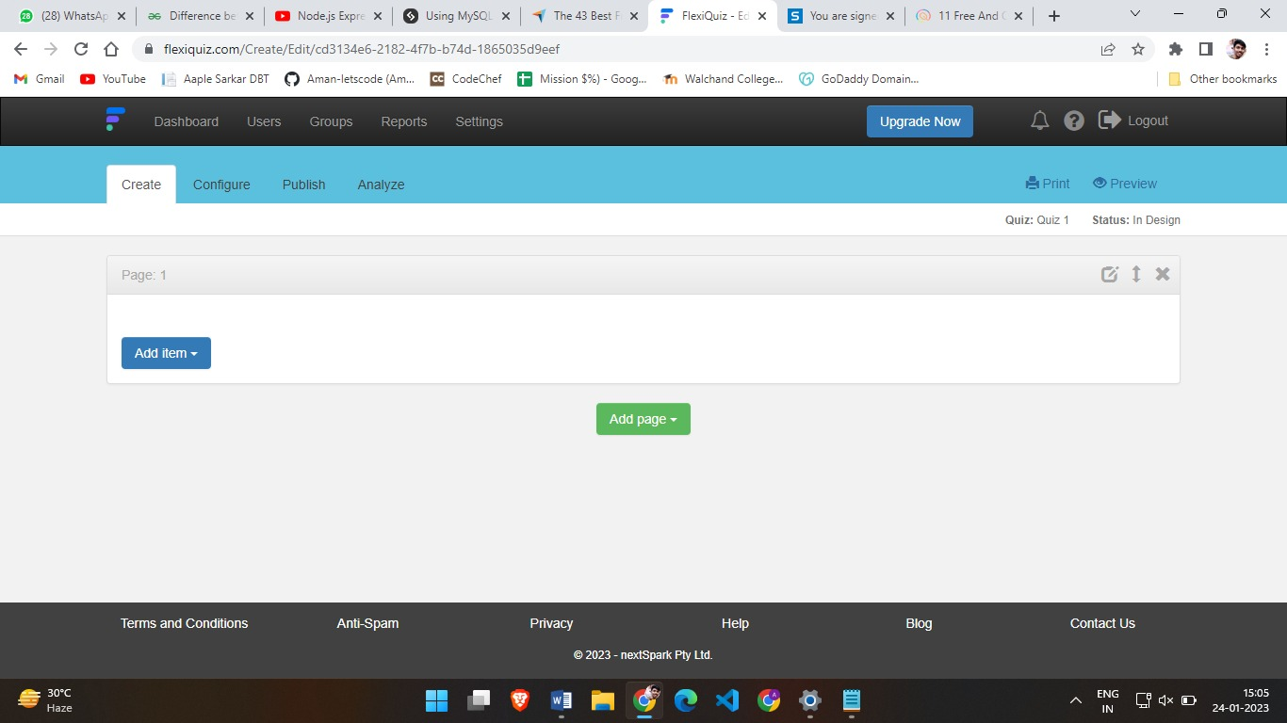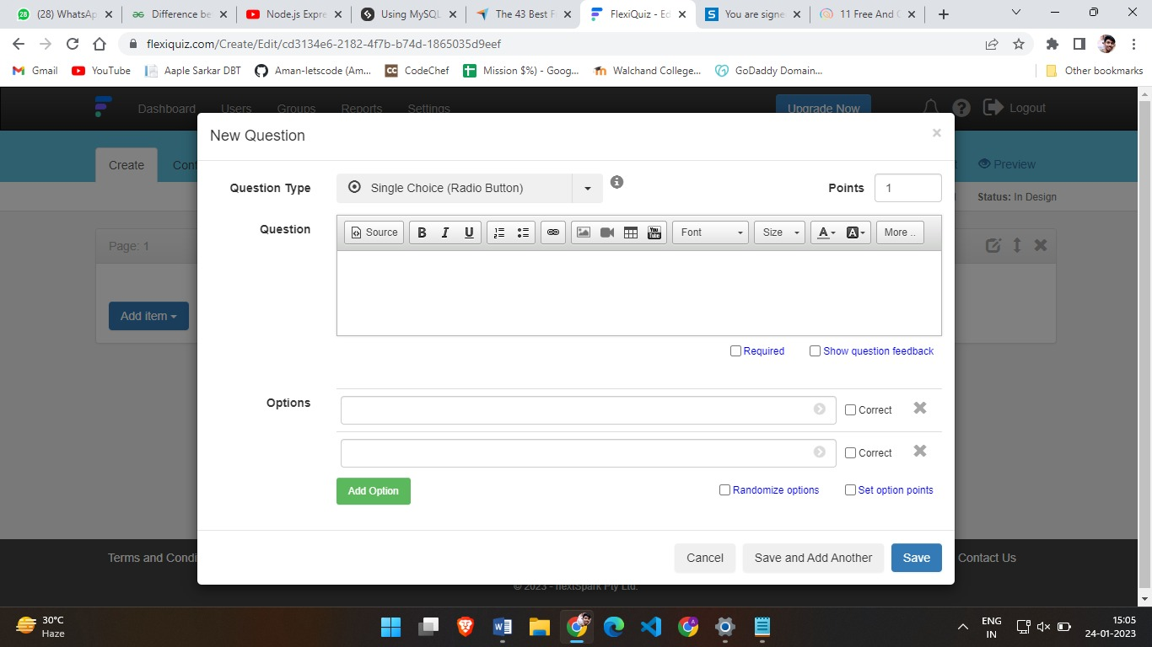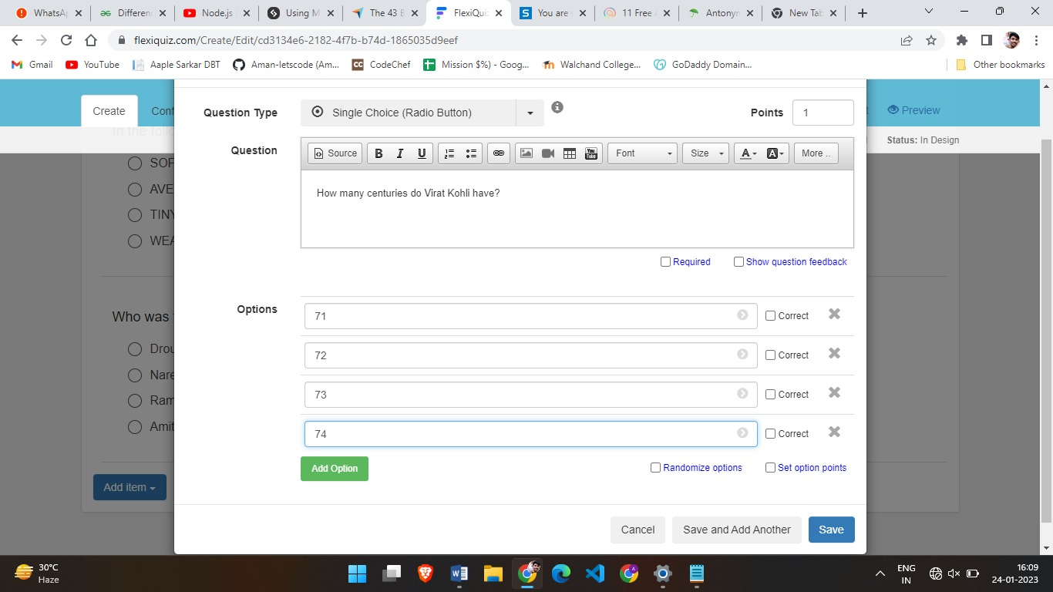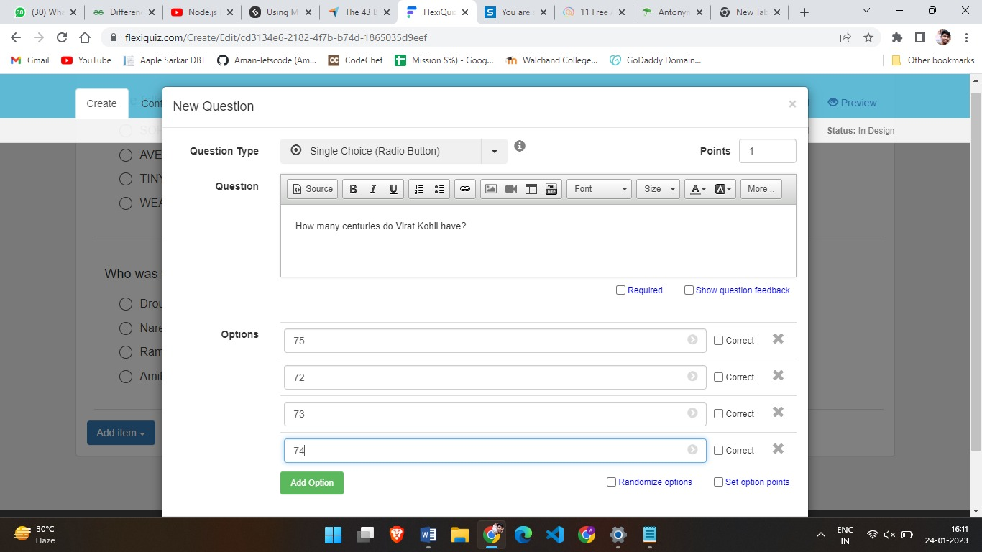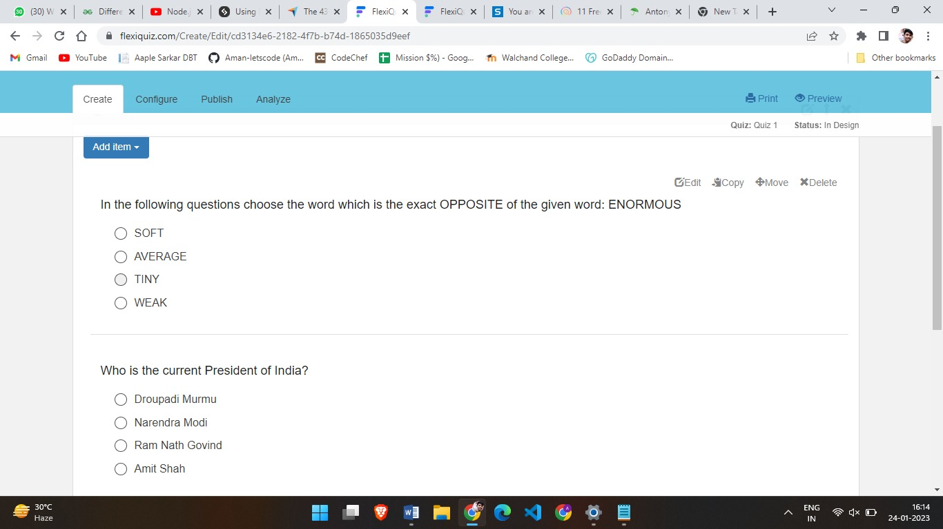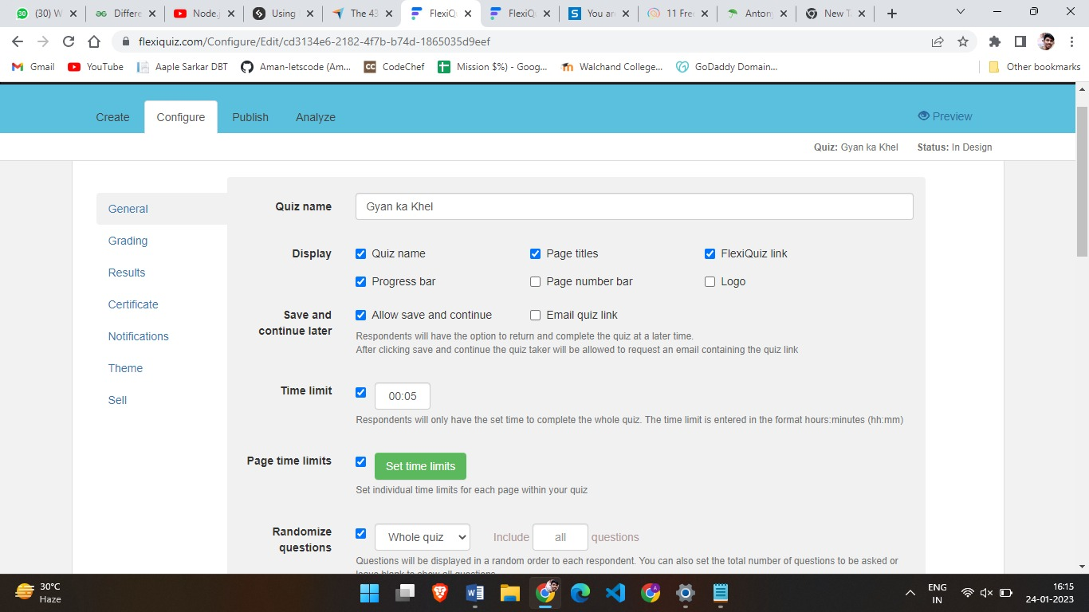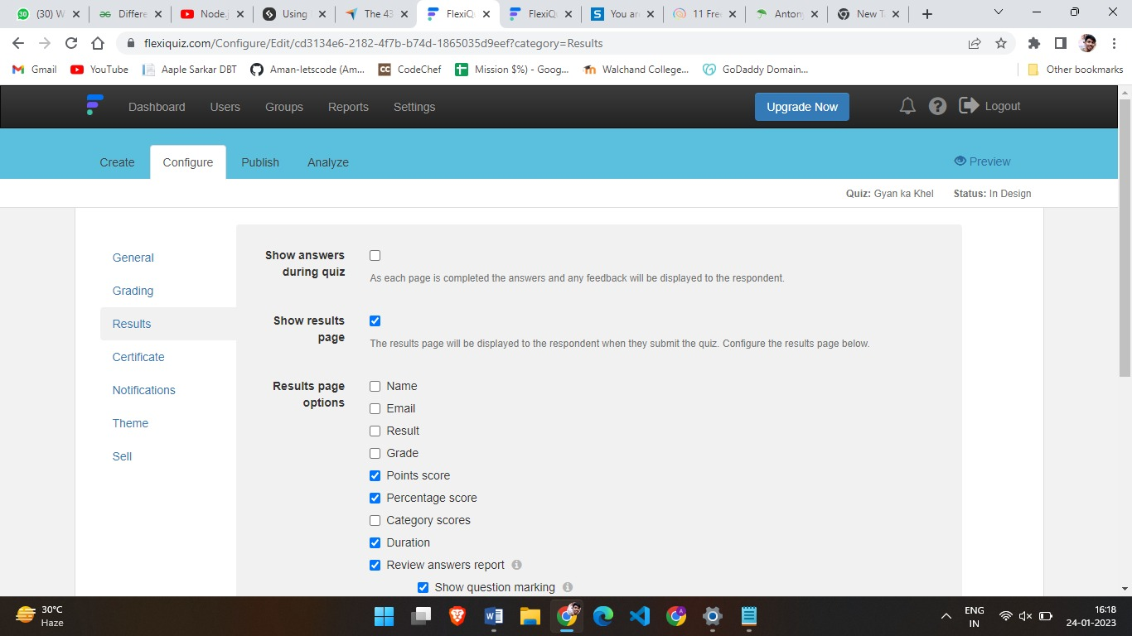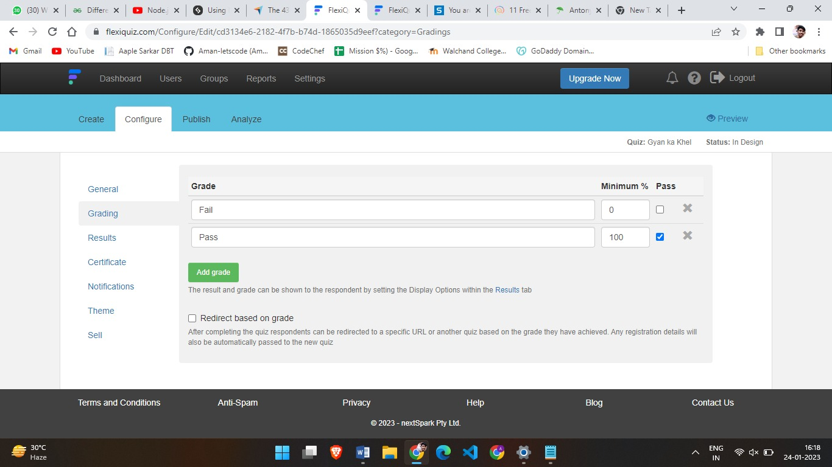

Exam Giving User Experience –

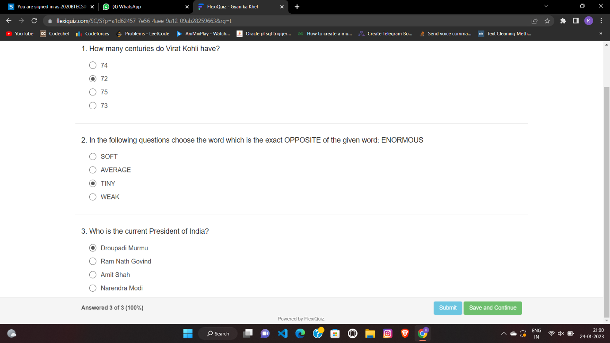

User gets list of questions which he can answer.

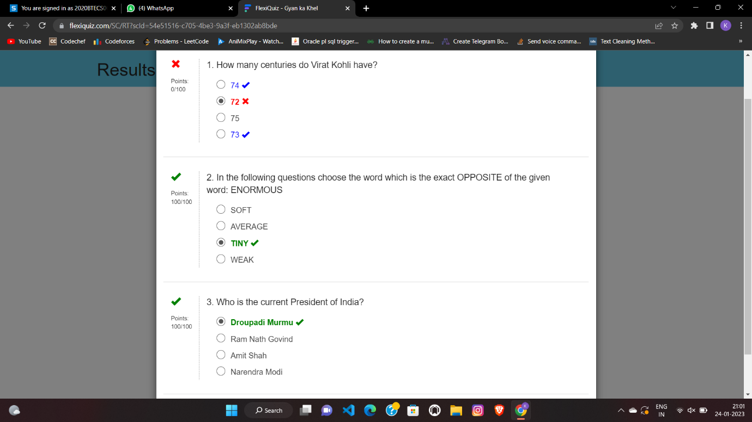

After submitting the test user can see the answer book compared with the ideal answer book.

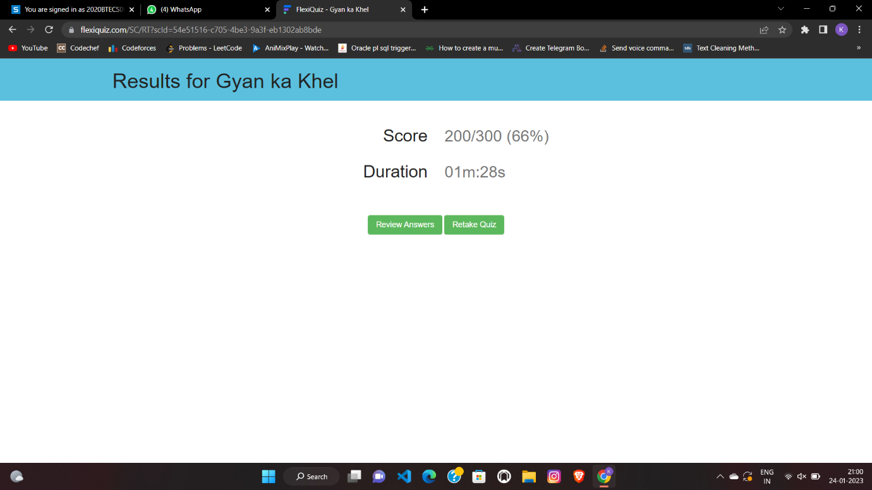

Software displays score after submission.

1. Demonstrate FOSS software related to database.

**Answer:**

FOSS software works similar to the commercial software you can use the database related FOSS software to store the data into it by using SQL or any other language. FOSS have advantages that it is open source and we can contribute into the source code and add new features into software and help it make useful for the user.

CREATE TABLE:

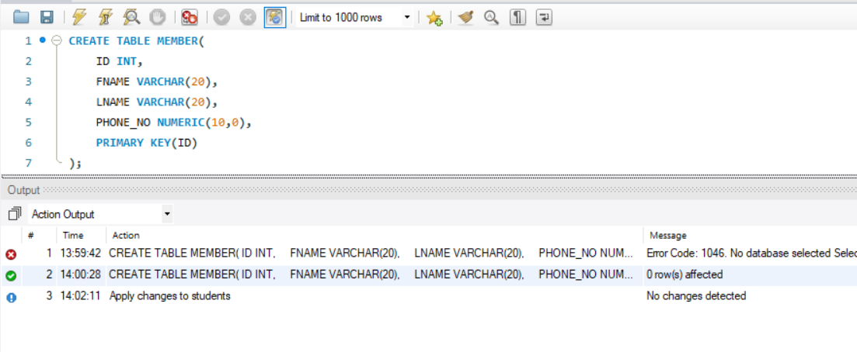

INSERT INTO TABLE:

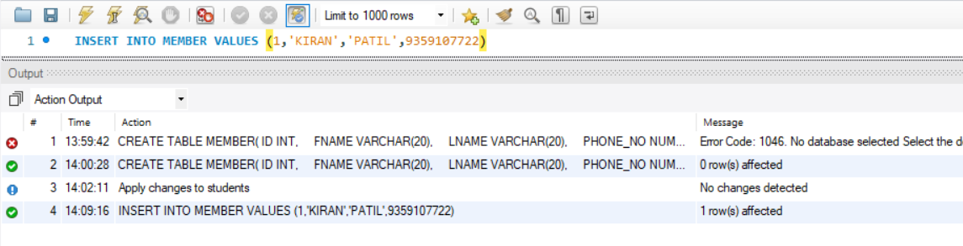

QUERY TABLE:

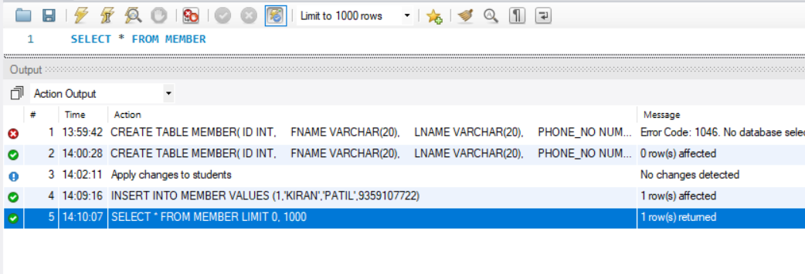

DELETE QUERY:

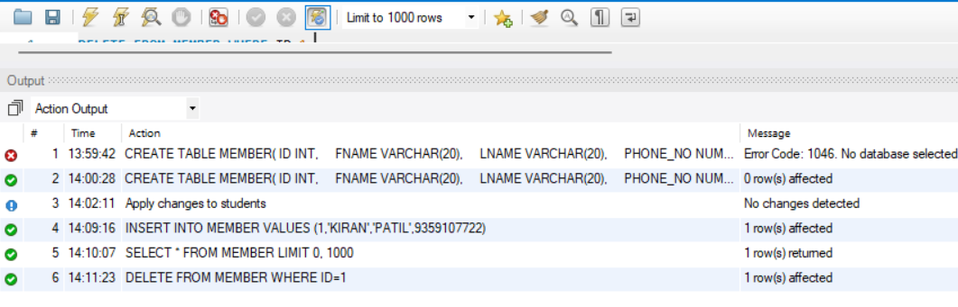

1. How does the Exam software work?

**Answer:**

Exam software has mainly three types of user one will monitor the users like admin, second one will set the question paper and lastly users who will attempt the questions.

Admin user – These users will manage the security and rights of the users. Responsible to handle new users and their permission. Data into the database of the software will be maintained by the admins.

Exam Setters – These users will add the tests and papers in the database by using the portal by login in to it and using permission provided to them.

Attempter – These user will attempt the test and will get the score according to it.